Using SleepAnalysis to Screen Sleep Apnea and Hypopnea.

1. Start SleepAnalysis.

2. Click on the Score on the Menu bar, in the Open dialog, navigate to the file folder that contains the respiration data. Then, select a file to open.

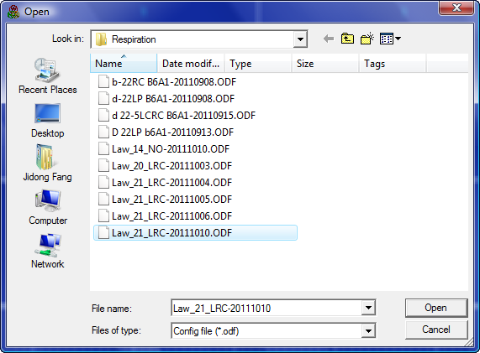

3. Now, you can see the Scoring Configuration window. You have two ways to start the apnea/hypopnea screening:

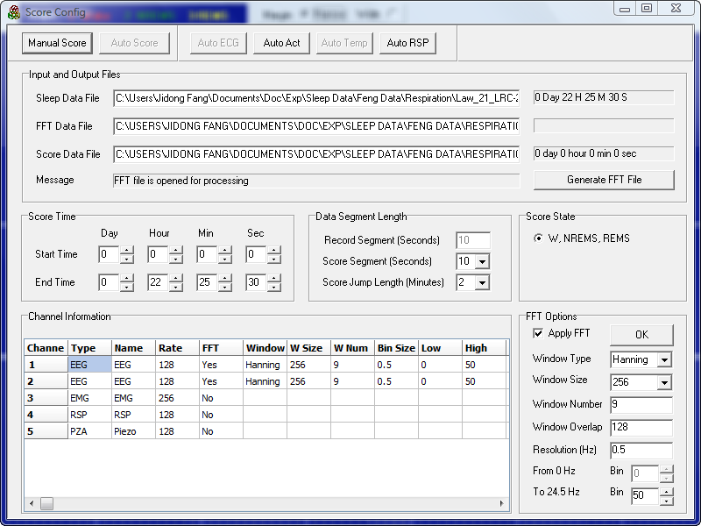

1) Click on the Auto RSP button on the top to start screening process and wait about half minutes, the results will show up;

2) Click on the Manual Score button to display graphic display of the data as in normal sleep scoring process, and then click on the RSP channel button to open the Respiration window.

Now, lest us to see the first way. Just click on the Auto RSP button, and wait.

After half minute or so, you will see the following:
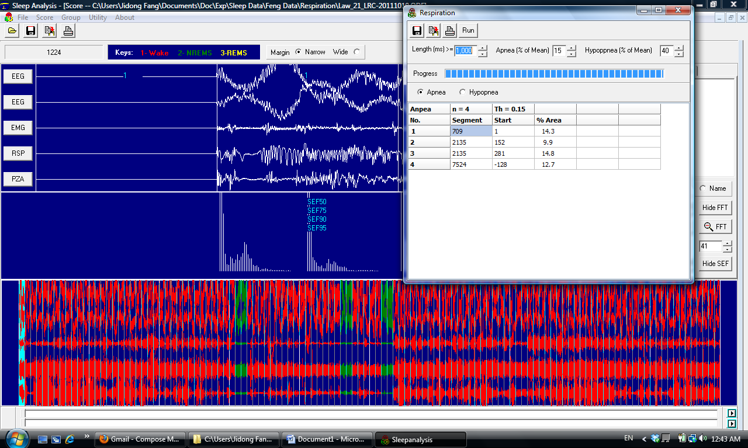

The Respiration window is opened on top of regular sleep scoring window. The Respiration window displays the parameter settings for the screening and the screening results.

4. Looking at the data in the Respiration window.
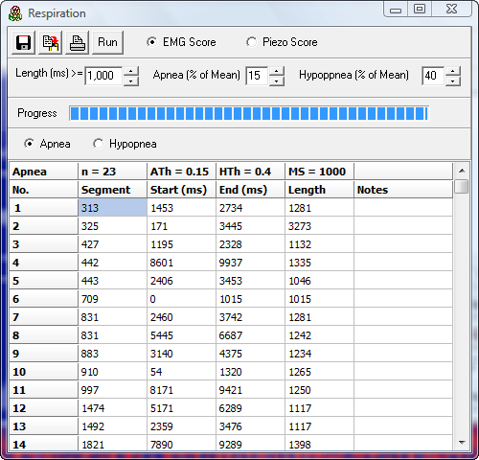

In the Respiration window, the Apnea data is listed:

Total apnea number = 23;
Threshold for apnea (ATh): In this case, area under curve is less than 15% of global average level.
Threshold for hypopnea (HTh): In this case, area under curve is less than 40% of global average level.
The minimal length of apnea/hypopnea (MS) in milliseconds: 1000 ms

Each Apnea event is listed for its position in the recording: segment, and starting point in the segment (for instance, the first apnea event occur in the Segment 313, starting for sample 1453 ms and ending at 2734 ms in that segment , with a duration of 1281 ms.

A click on the first apnea row on the data list will bring the display to the segment where this apnea event occurred. A click on the next row will bring you to the second apnea event, which is on the 325 segment. See the following screen capture.

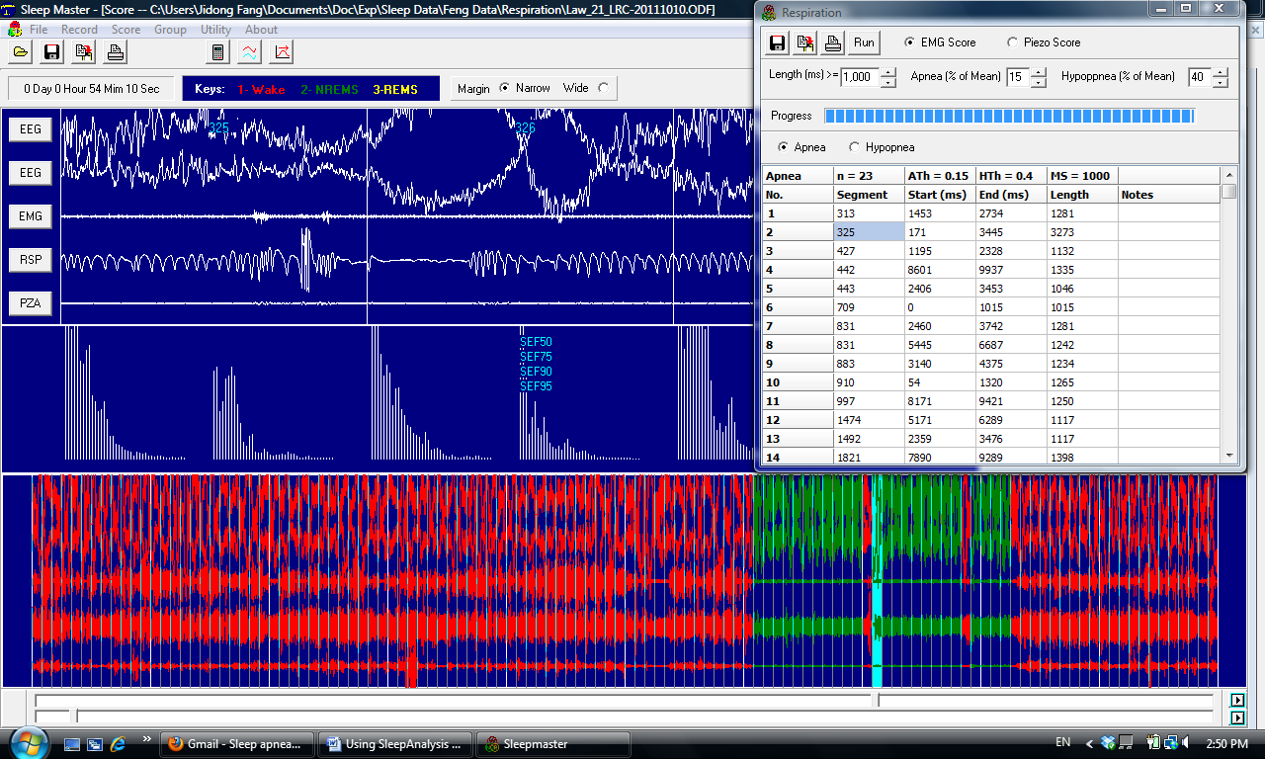

This appears to be a post arousal event.

Click on the next line, you will find the display for the next apnea event. You can move up and down on the list in any way you want to see the data. Sometimes, a single segment may contain several events.
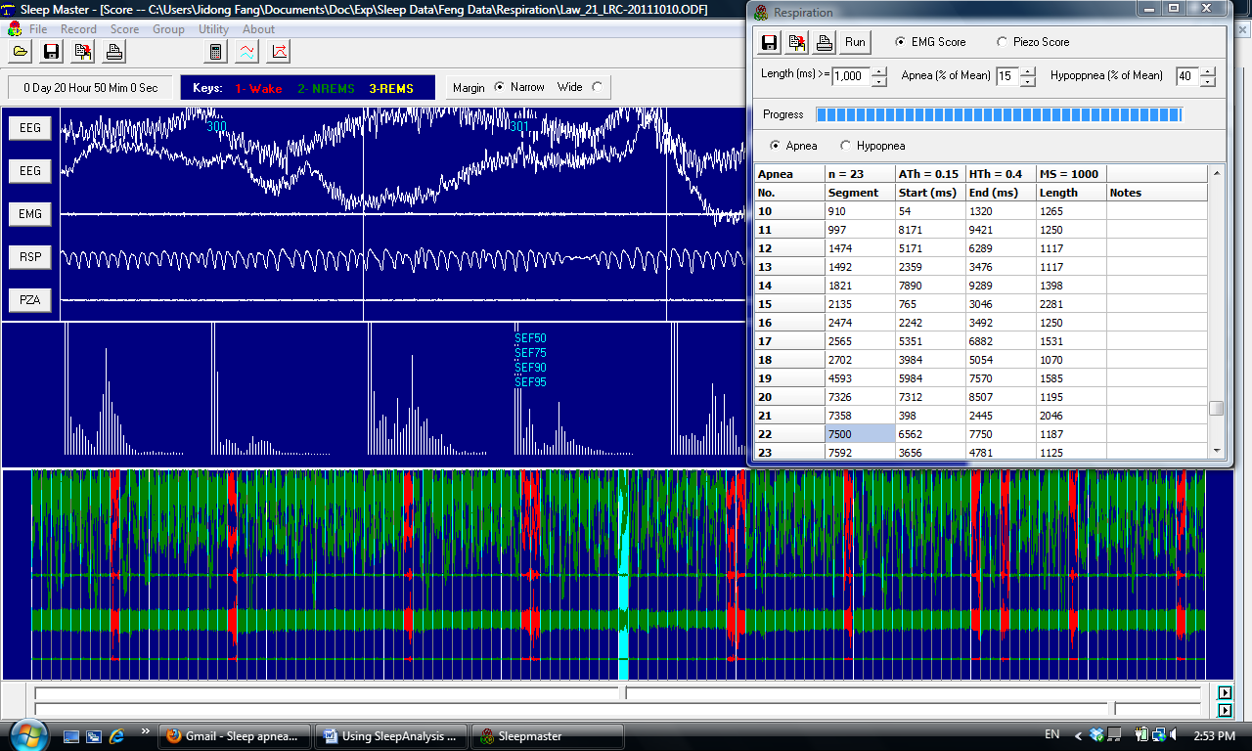

Here is another event, which occurred in REM sleep.
In the above screen captures, apnea events are displayed because the Apnea Radio button had been checked.

If you click on the Hypopnea radio button, the hypopnea events will be listed, as shown in the following screen capture:
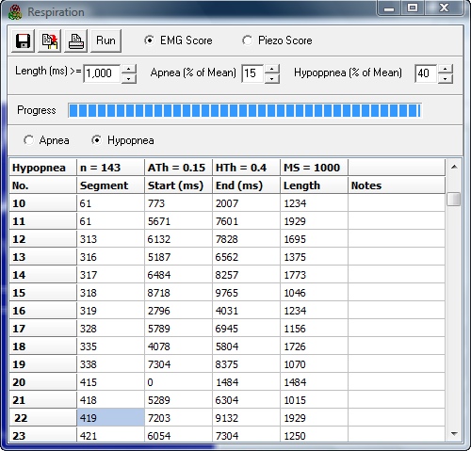
You can move up and down to find the wave form corresponding to a particular hypopnea event, as you did with apnea event. Here is an example in REM sleep:

Note: the next 4 screen captured were obtained with older version of the program.

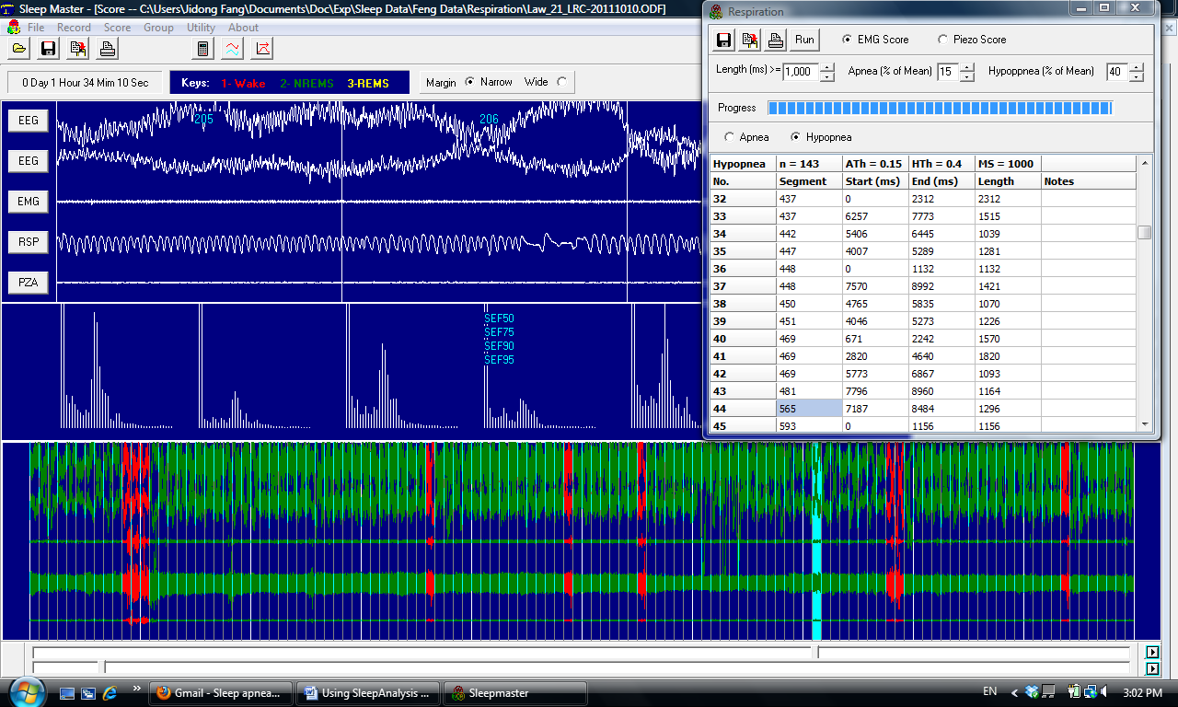

Here is another example (this one occurred in NREM sleep):
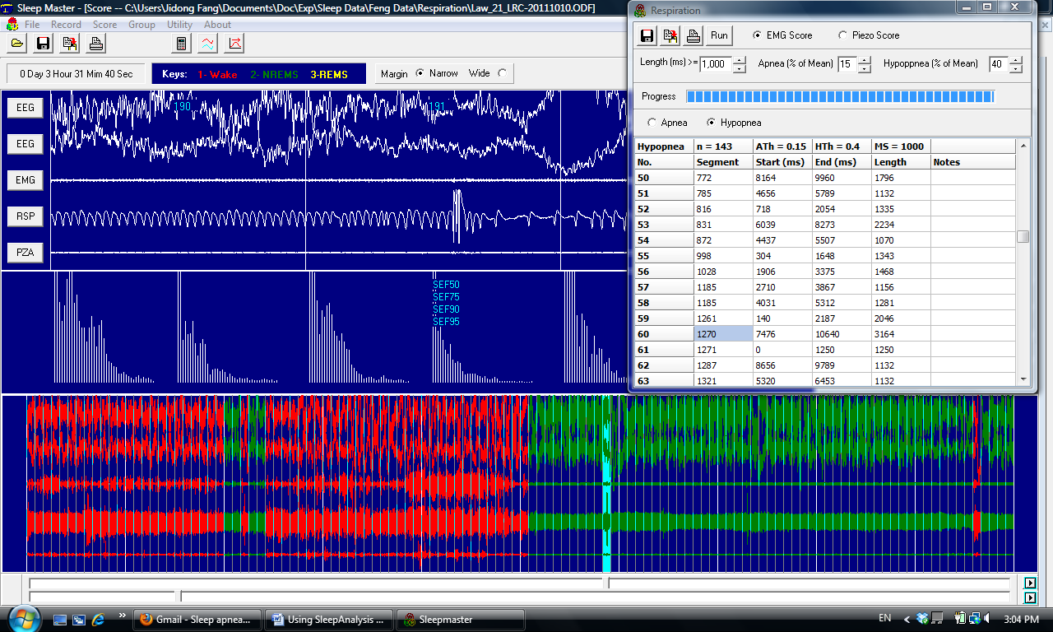
Here is a cluster of apnea and hypopnea events found in the same segment: 2 apnea events (starting at 2440 ms and 5445 ms) were counted before the hypopnea event (starting at 6039 ms).
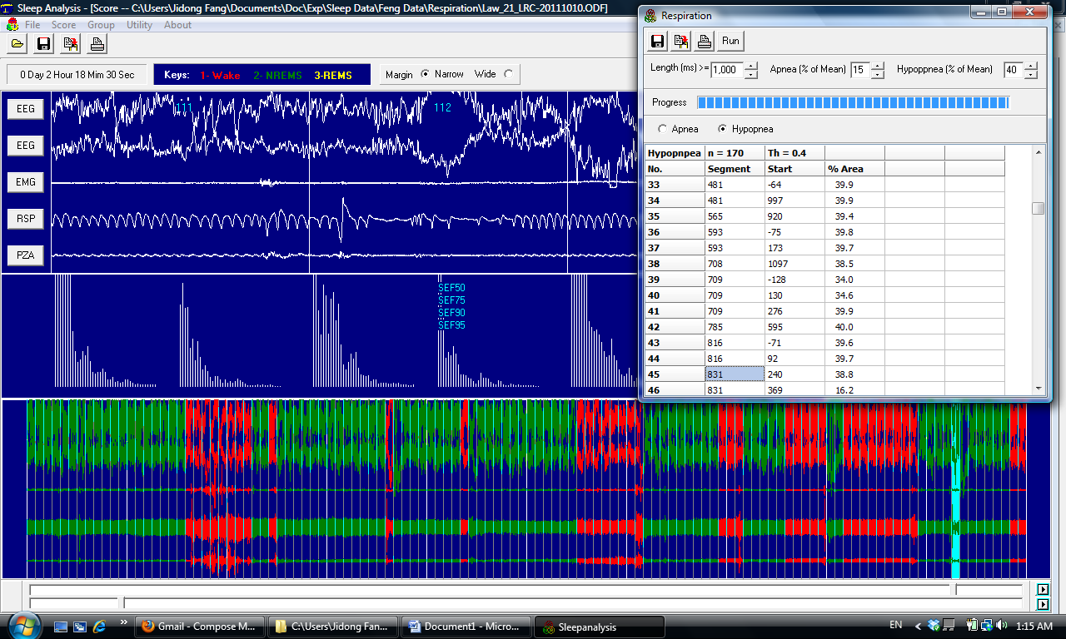

Here is a long hypopnea found in REM sleep (the program counted it as two hypopnea events:
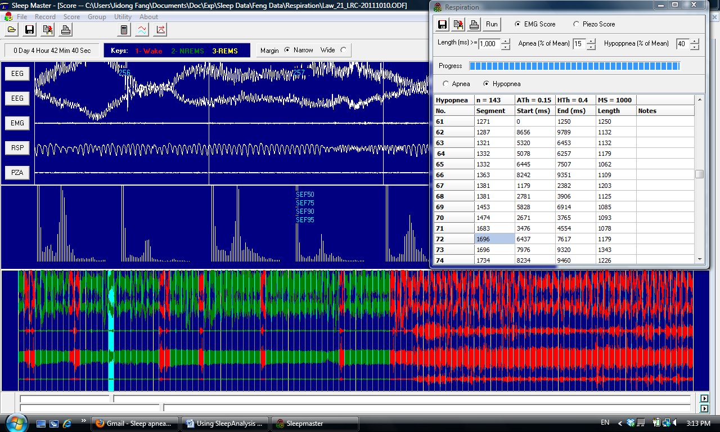

The following screen captures were from a different animal with the new version of the program.

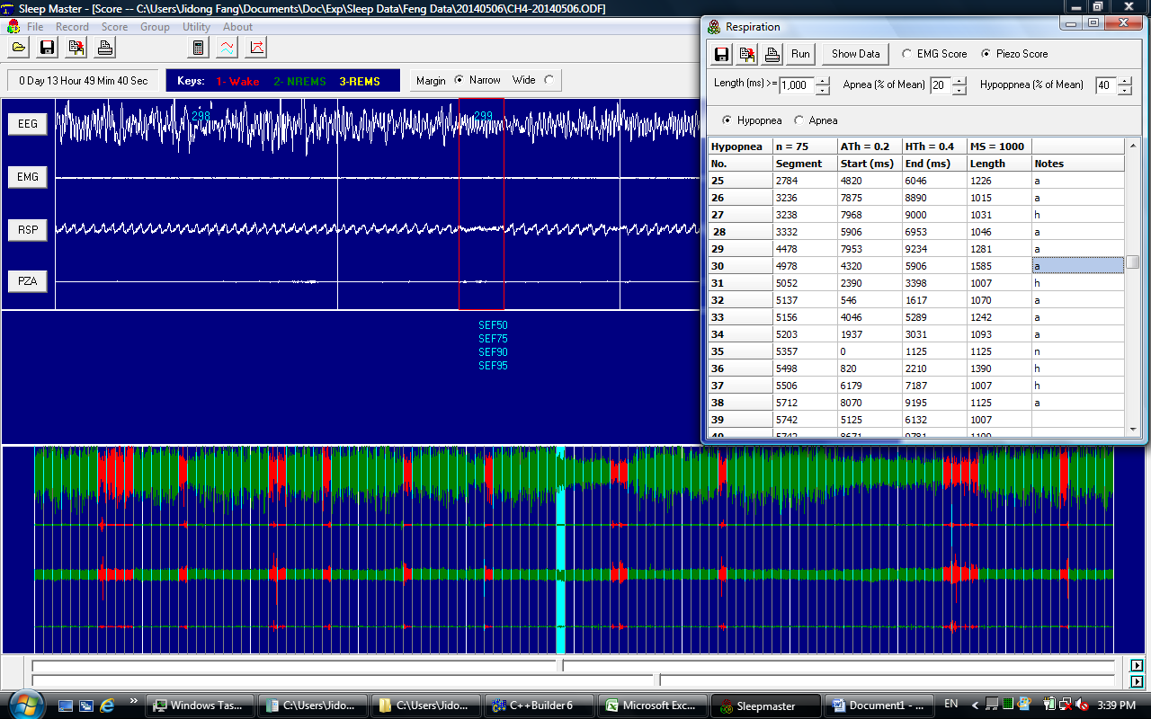

There is a Notes column in the Respiration Window. The users can go to any row to look at the raw data and enter visual scoring. For instance, typing in “a”, “h” or “n” for “apnea”, “hypopnea” or “not apnea/hypopnea”, respectively. In this way, the autoscoring results can be verified and corrected.

In the above screen capture, apnea – indicated in Notes column as “a” in the RSP window shown in the upright corner.

The apnea is enclosed in the red frame in the Scoring Window. In this case, the program’s AutoRSP score it as hypopnea, but it might actually be an anpea.

The verified and corrected results can be copied to clipboard using the Copy button in the Respiration window, and pasted to other Windows programs such as Excel.

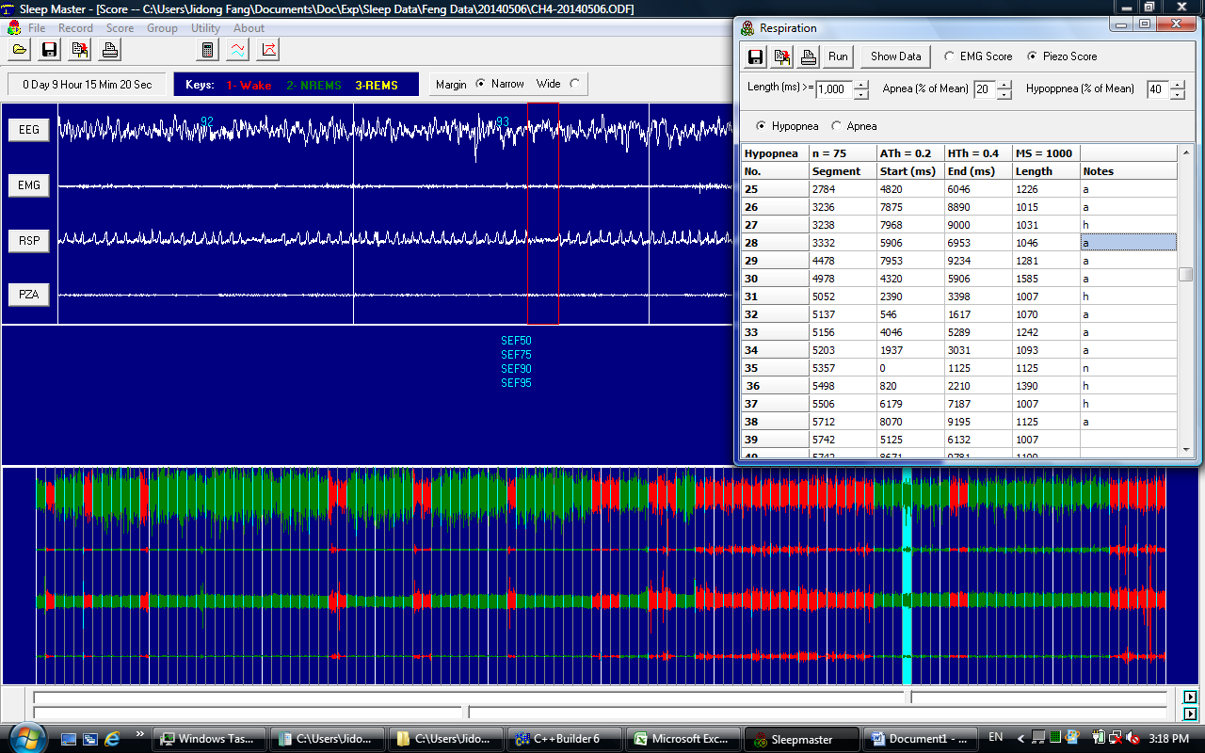

In the current version of the program, by far the most of events are hypopneas, few or none of apnea event can be detected. This might be related to the default threshold setting. So it is important to evaluate the program under different threshold settings.

Another screen capture, the program shows a hypopnea event, but this could be an apnea as indicated in the Notes column.
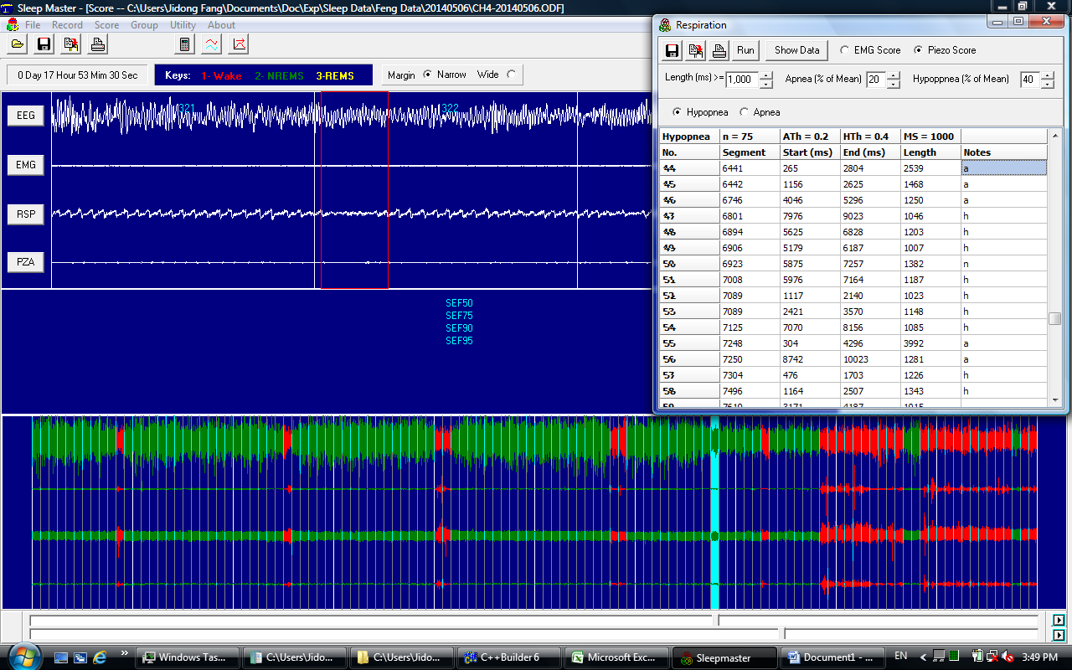Here is a long apnea.

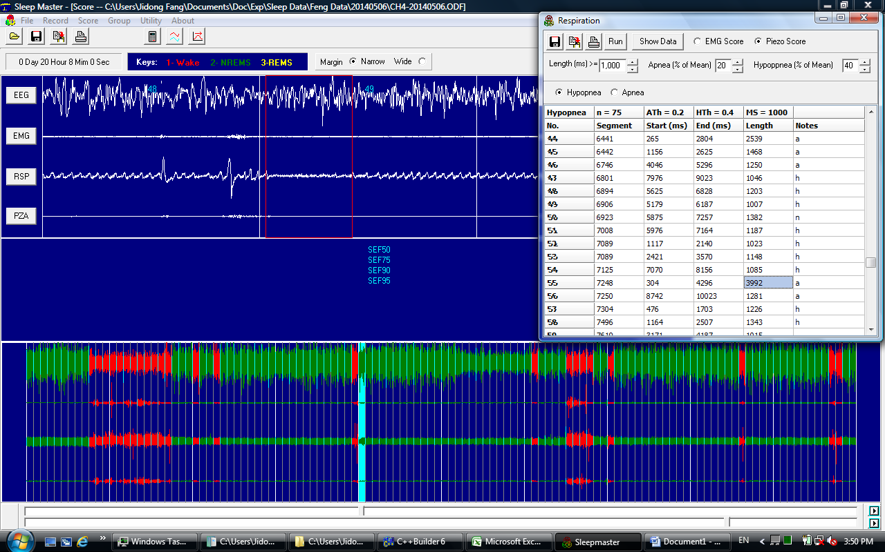

Here is a long apnea after a brief arousal.

6. Saving data to XLS file and copy data to clipboard.
In the up-left corner of the Respiration window, there is a Save button, and a Copy button, a click on the button will perform corresponding saving or copying function.

7. Setting the Screen parameters.
You can change the screen thresholds: Minimal length (in number of milliseconds) for apnea/hypopnea event; the maximal area values for apnea and hypopnea. After you changed the values, click on the run button will restart the screening and generate different results from the same original data.

8. Bring up Respiration window from Scoring window.
If you got into the Scoring window without clicking on the Auto RSP button, you can click on the RSP channel button to open the Respiration window, and perform screening from there.

9. Using EMG versus piezo floor sensor for sleep scoring.
In the sleep apnea/hypopnea screening process, the animal’s sleep-waking state is first automatically scored according to EMG signals or piezo floor sensor signals.

By default, SleepAnalysis uses EMG signals for automatic scoring of sleep. This is indicated by the “EMG Score” radio box in the Respiration window, which has been checked when the program started.

If you need to use piezo floor sensor signals to score sleep, just click on the “Piezo Score” radio button and then click the Run button on the Respiration Window.

Note: the program assumes that there is an EMG channel in the recording if you checked EMG Score button, and assumes that there is a Piezo channel if you checked the Piezo Score button. In the current version, SleepAnalysis program does not check the presence of these channels. So if the corresponding channel does not exist in the data file, the program may not be able to allocate memory and may generate “access violation” error after you click on the Run button.

