Using SleepWave and Floor Sensor Technology to Rapidly Screen Sleep in Mice
Assuming you have used SleepWave and collected mouse data containing floor sensor (piezo sensor) signals, you can use SleepAnalysis to get the sleep data in just one minute. Here is how to do it.
Step 1. Start SleepAnalysys.
Step 2. Find the data file. First click on the Score button in the main window’s tool bar of SleepAnalysis. Next, in the Open dialog, navigate through the folders to find the correct file with file extension “.ODF”. Then, click the Open button
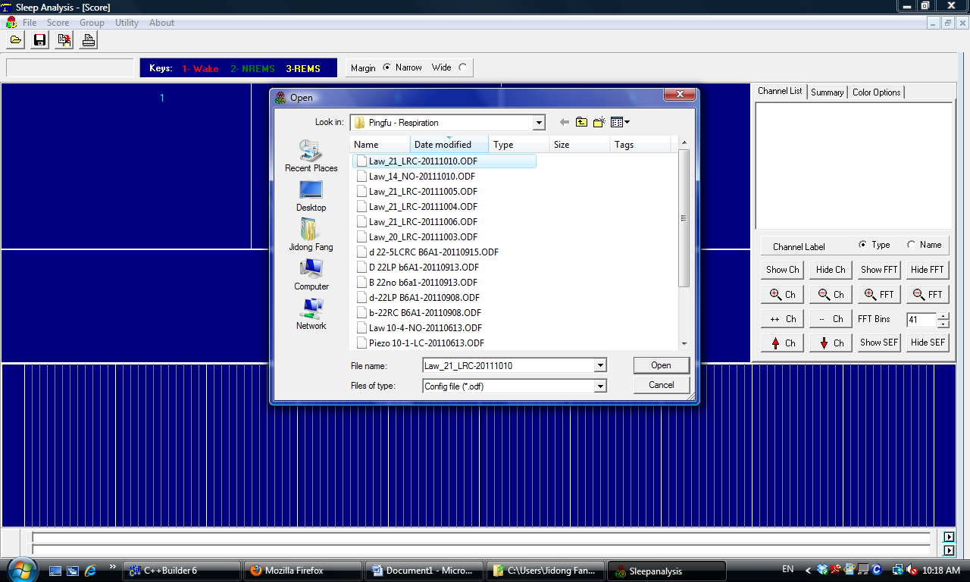
Step 3. Create a new Score file. After the Step two, a message box will popup if this is the first time you opened this file. You can simply click the OK button in the message box.
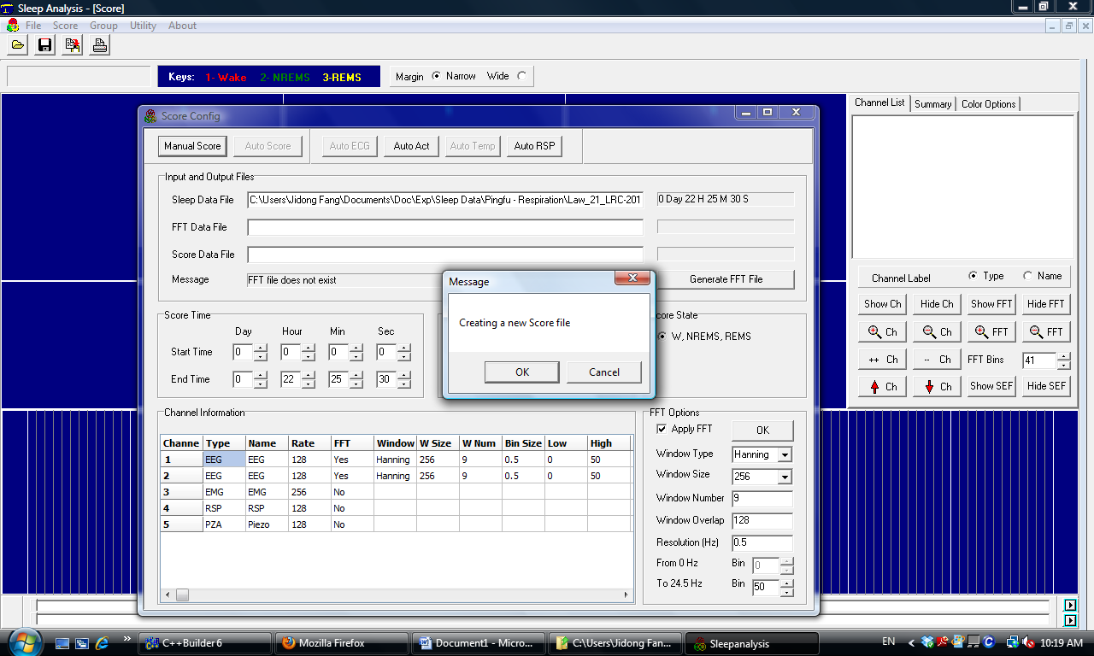
Step 4. Click on the AutoAct button on the top of the Scoring Config window. This will initiate the automatic scoring process. It may take several seconds, you just need to wait a little bit.
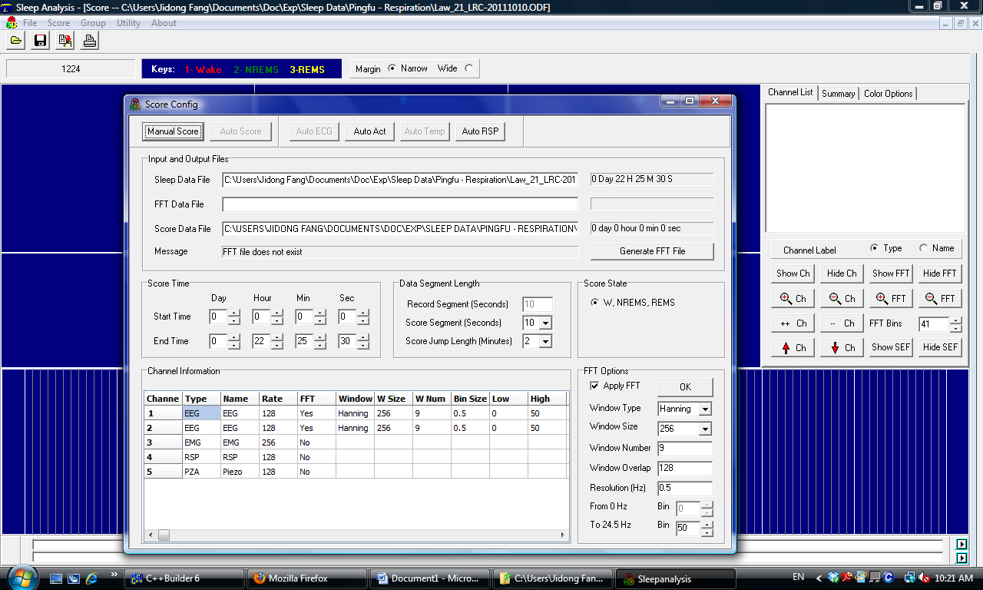

Step 5. To look at the data and sleep patterns visually. The Scoring window (shown below) now will be filled with traces. Here we have multiple channels: 2 EEG channels, 1 EMG channel, 1 respiration (RSP) channel, and 1 floor sensor (PZA) channel. When you perform, rapid sleep screening, you only need the PZA channel. The RSP and PZA channel signals appears too big, so you need to reduce them to see the data more clearly. First, select the RSP channel and then click on “-- Ch” button several times. This will quickly reduce the display amplitude of RSP channel.
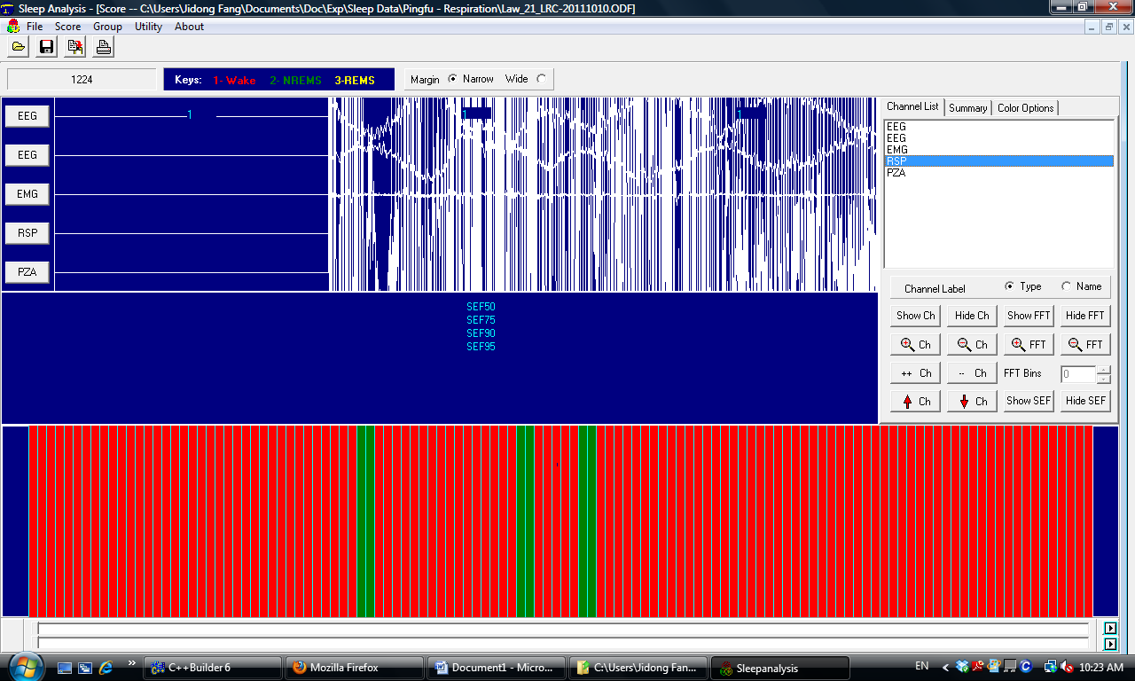
Next, select the PZA channel, click on the “-- Ch” button several times again.
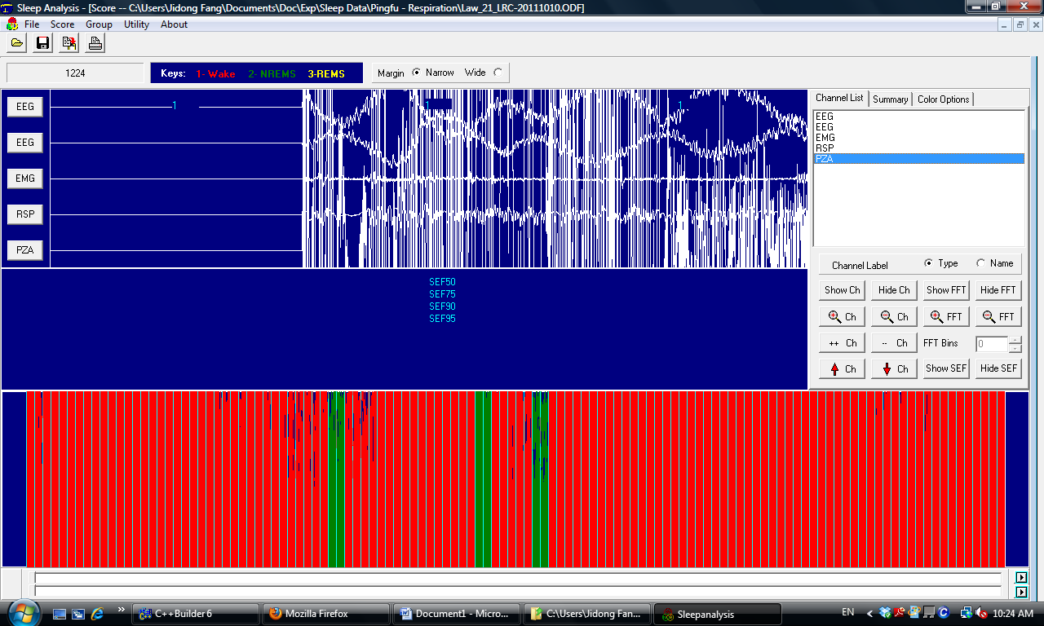
Now, you can see the recording traces better. You can also hide the channel(s) you don’t want to see, for instance the second EEG channel in this case.
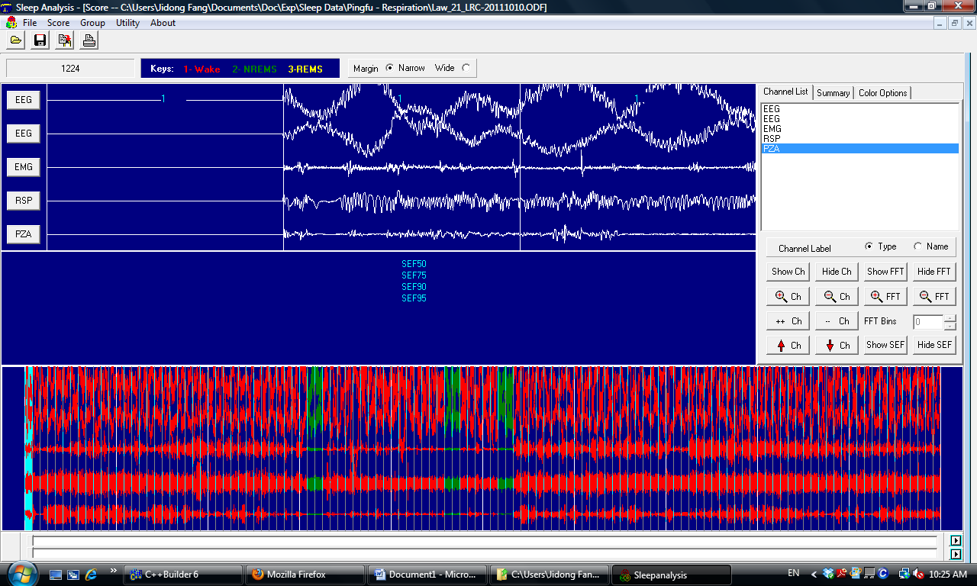
Then, you can use the scrolling bar at the bottom to navigate through the recordings.
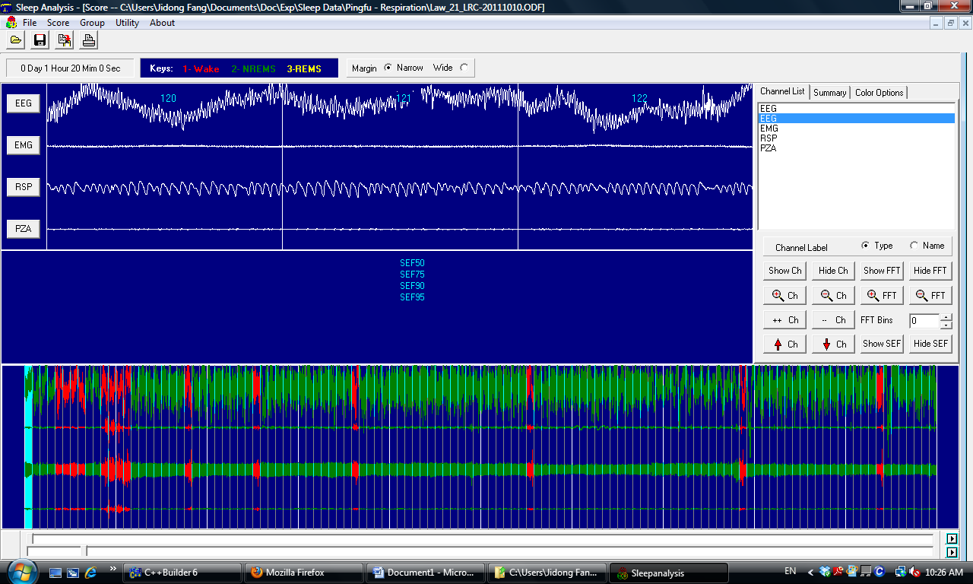

Step 6. Find the summary data. On the upper right side of the Scoring Window, you can find the Summary tab page. Click on the Summary tab page, you can see the hourly values for the amounts of Wakefulness and NREM sleep (displayed as minutes by default). Actually, the NREM sleep column displays the total amounts of sleep, but not just NREM sleep, since REM sleep cannot be differentiated from NREM sleep according to floor sensor signals alone.
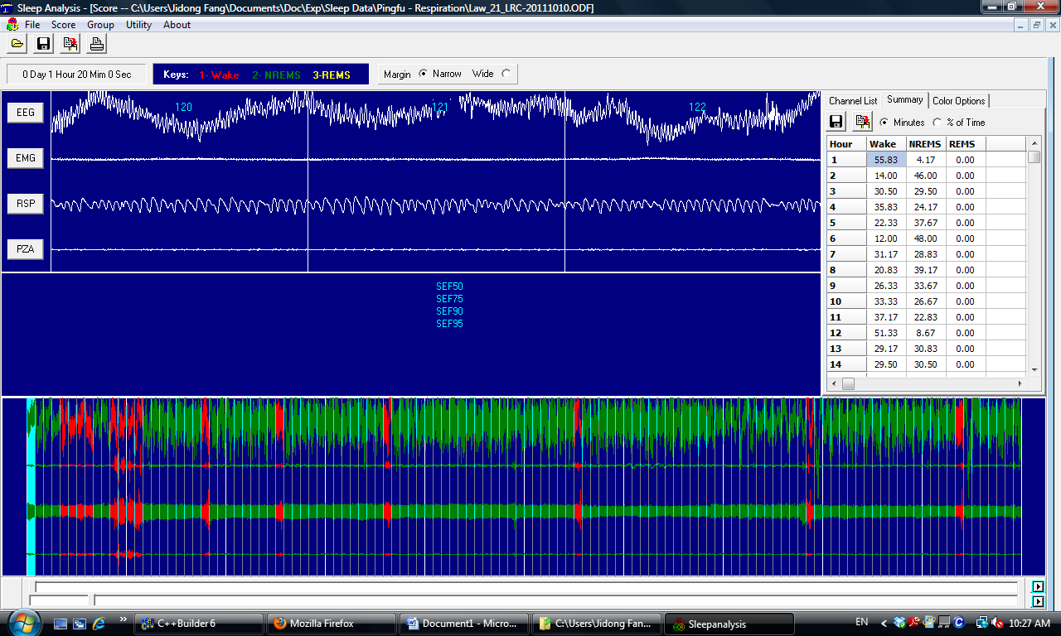
On up left corner of the Summary tab page, there are two buttons which allows you to save the summary data to a text file or copy the summary to Window’s clipboard. Move the mouse cursor over the button, you can see the button on the right is the Copy button.
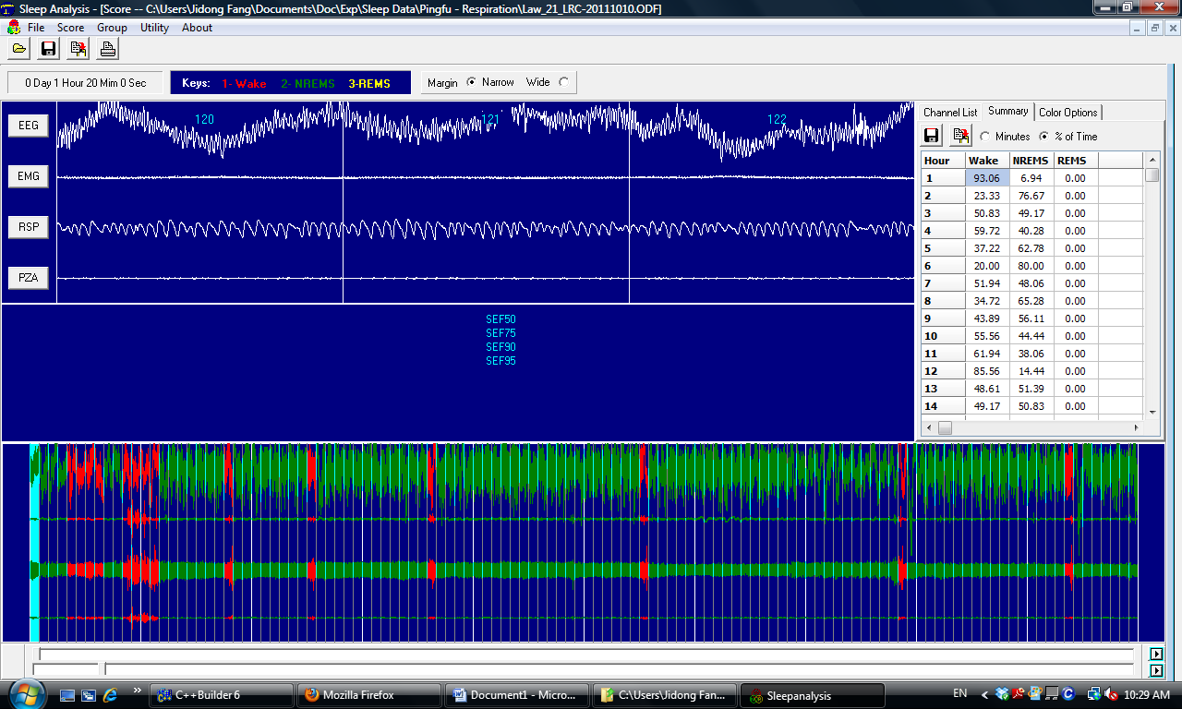
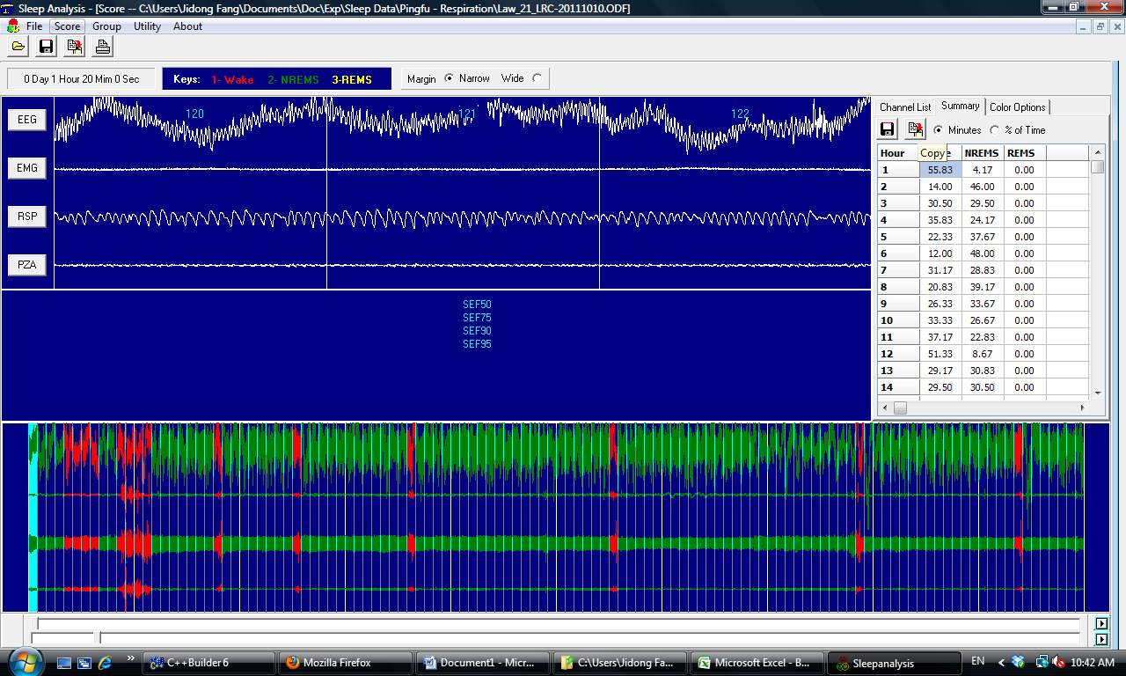
Click on the Copy button, the summary data are now copied to the clipboard.
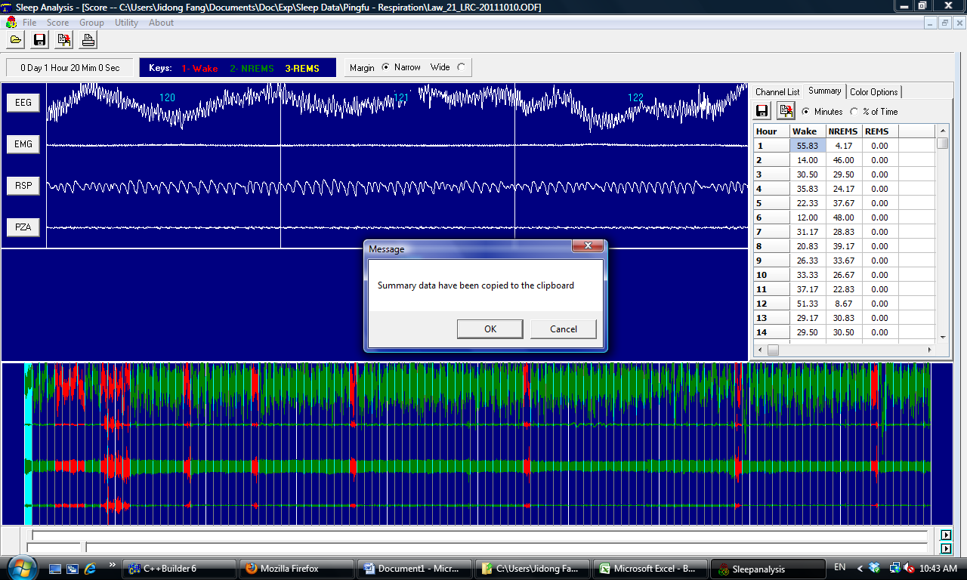

Now, open the Excel, click on the Paste button, your sleep summary data are now in the Excel.
Now you can save the Excel file. You can now close the Scoring Window in the SleepAnalysis. Next, you can quit from SleepAnalysis, or repeat Step 2 to Step 6 to work on additional original data files and put sleep data from multiple animals into the same Excel file.

